kubectl apply -f act4-deployment.yml

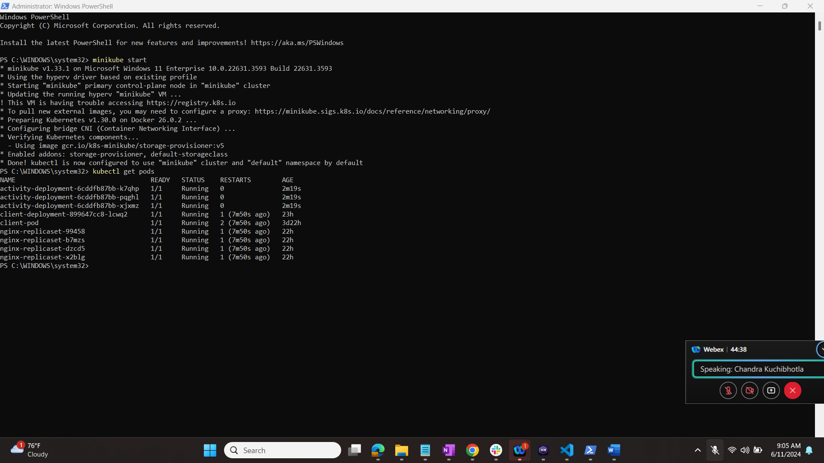

kubectl describe deployment activity-deployment

# Modify the deployment to use nginx instead of caddy.

$ kubectl apply -f act4-deployment.yml

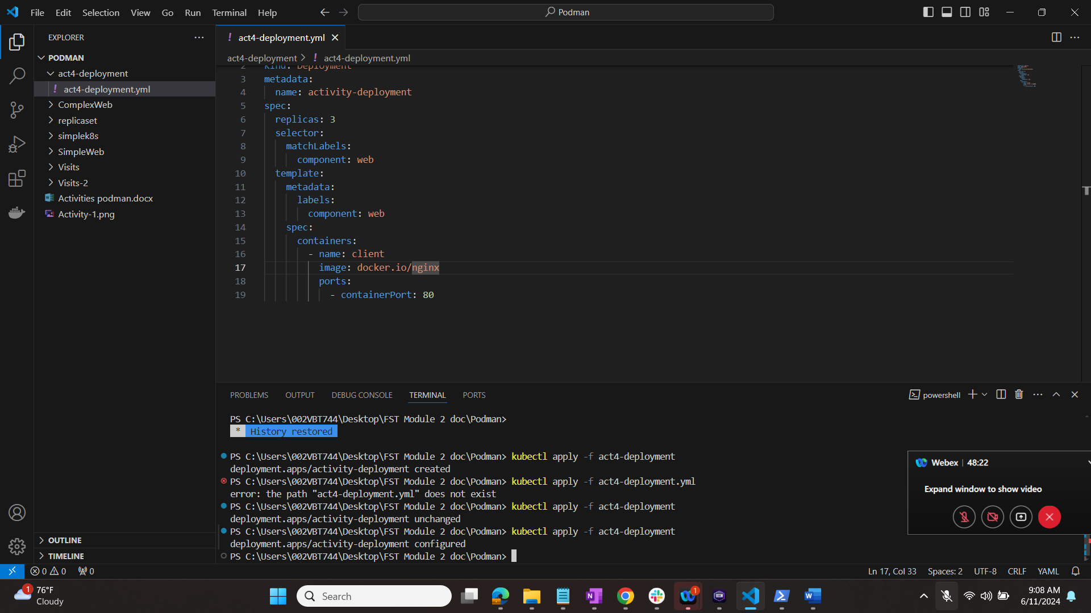

# Verify that the pods are now running nginx.

$ kubectl describe deployment activity-deployment

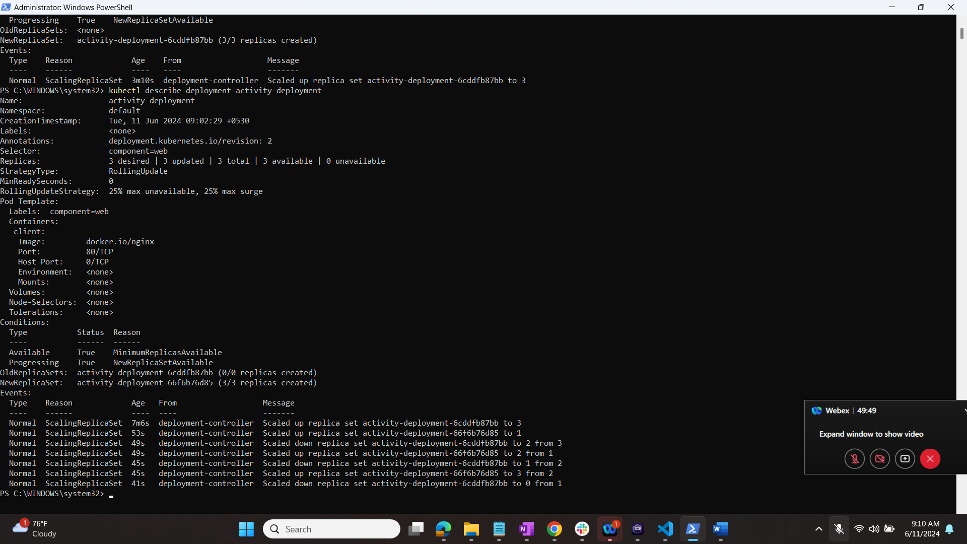

# Rollback the deployment and verify that the pods are once again running caddy.

$ kubectl rollout undo deployments/activity-deployment

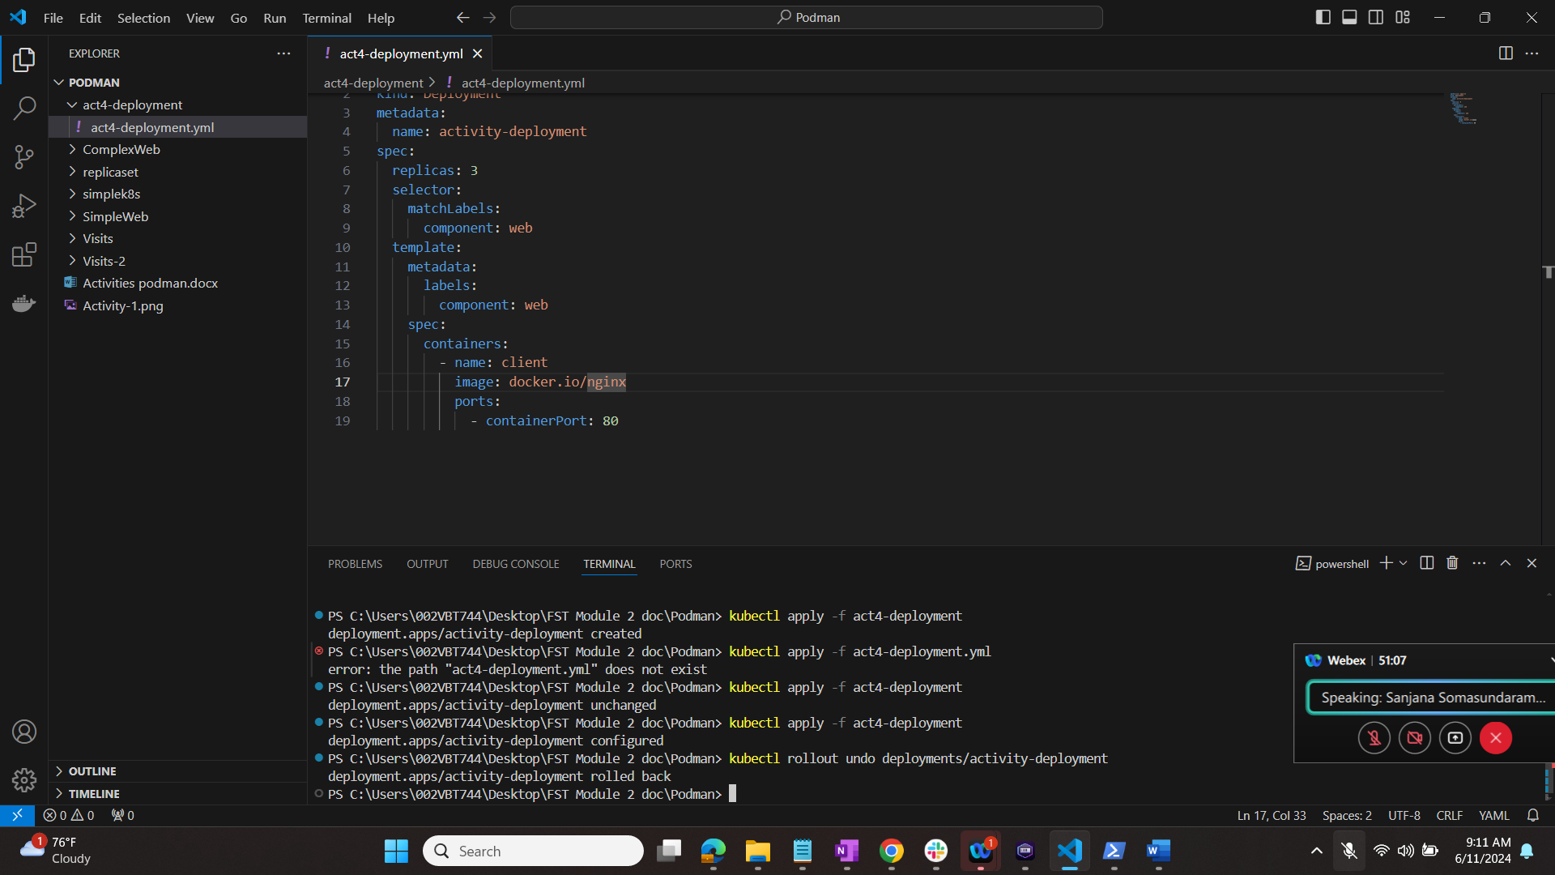

# Verify that the deployment went back to the previous config.

$ kubectl describe deployment activity-deployment

